AI Assisted Coding-8.3
A. || Batch-09 || 2303A51649
Task 1: Email Validation using TDD
Scenario: You are developing a user registration system that requires reliable email input validation. Code:
#Task-01 def validate_email(email):
"""Validates email address based on specified requirements."""
# Check for required characters if '@' not in email or '.' not in email:
return False

# Check for multiple @ symbols if email.count('@') > 1:
return False

# Check if starts or ends with special characters special_chars = "!#$%^&*()_+-=[]{}|;:,.<>?/\\" if email[0] in special_chars or email[-1] in special_chars:
return False

return True
def register_user(email):
"""User registration with email validation.""" if validate_email(email):
return True else: return False
# Test the registration system if __name__ == "__main__": test_emails = [
"user@example.com", # Valid
"invalid.email", # Missing @
"@invalid.com", # Starts with @
"invalid@.com", # Invalid format
"user@@example.com", # Multiple @ "user@example.com.", # Ends with .
]

print("--- Email Validation Test ---") print(f"{'Email':<25} | {'Valid':<7} | {'Status':<20}") print("-" * 55)

for email in test_emails:
result = register_user(email) status = "Registration successful" if result else "Invalid email address" print(f"{email:<25} | {str(result):<7} | {status:<20}") Output:
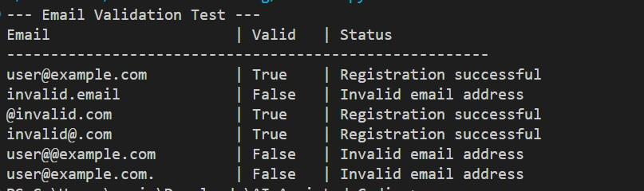
Task 2: Grade Assignment using Loops
Scenario: You are building an automated grading system for an online examination platform.
Code:
def assign_grade(score):
"""Assigns a grade based on the score.""" if isinstance(score, bool) or not isinstance(score, (int, float)):
return "Invalid input"

if score < 0 or score > 100:
return "Invalid input"

if score >= 90: return "A" elif score >= 80: return "B"
elif score >= 70: return "C" elif score >= 60: return "D" else: return "F"
def test_grading_system():
"""Test cases for the grading system.""" test_cases = [
# Valid boundary cases
(90, "A"),
(80, "B"),
(70, "C"),
(60, "D"),
(59, "F"),
# Valid ranges
(95, "A"),
(85, "B"),
(75, "C"),
(65, "D"),
(45, "F"),
# Invalid inputs
(-5, "Invalid input"),
(105, "Invalid input"),
("eighty", "Invalid input"),
(None, "Invalid input"),
(True, "Invalid input"),
]

print("--- Automated Grading System Test ---") passed = 0 failed = 0

for score, expected_grade in test_cases:
result = assign_grade(score) status = "PASS" if result == expected_grade else "FAIL" if status == "PASS":
passed += 1 else:
failed += 1

print(f"Score: {str(score):>6} | Expected: {expected_grade:>15} | Got: {result:>15} | {status}")

print(f"\nTotal Tests: {passed + failed} | Passed: {passed} | Failed: {failed}")
# Run tests if __name__ == "__main__": test_grading_system() Output:
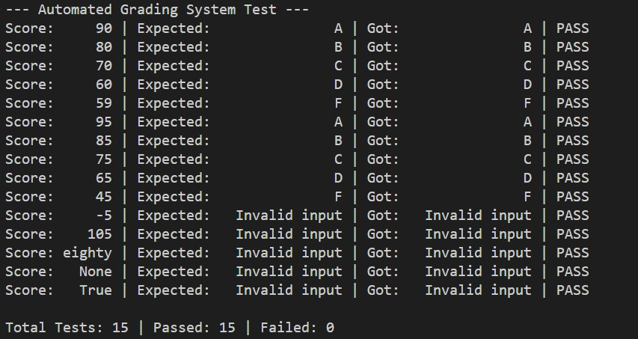
Task 3: Sentence Palindrome Checker
Scenario: You are developing a text-processing utility to analyze sentences.
Code:
def is_sentence_palindrome(sentence):
"""
Checks if a sentence is a palindrome, ignoring case, spaces, and punctuation.
"""
# Remove non-alphanumeric characters and convert to lowercase
cleaned = ''.join(char.lower() for char in sentence if char.isalnum())

# Check if the cleaned string equals its reverse return cleaned == cleaned[::-1]
def test_sentence_palindrome():
"""Test cases for the sentence palindrome checker.""" test_cases = [
# Palindromic sentences
("A man, a plan, a canal: Panama", True),
("race car", True),
("Was it a car or a cat I saw?", True),
("Madam", True),
("No 'x' in Nixon", True),
# Non-palindromic sentences
("Hello World", False),
("Python is great", False),
("The quick brown fox", False),
("Not a palindrome", False),
("Programming", False),
]

print("--- Sentence Palindrome Checker Test ---") passed = 0 failed = 0

# Print table header print(f"{'Sentence':<40} | {'Expected':<10} | {'Got':<10} | {'Status':<6}") print("-" * 70)

for sentence, expected in test_cases:
result = is_sentence_palindrome(sentence) status = "PASS" if result == expected else "FAIL"

if status == "PASS":
passed += 1 else:
failed += 1
print(f"{sentence:<40} | {str(expected):<10} | {str(result):<10} | {status:<6}")

print("-" * 70) print(f"Total Tests: {passed + failed} | Passed: {passed} | Failed: {failed}")
# Run tests if __name__ == "__main__": test_sentence_palindrome() Output:
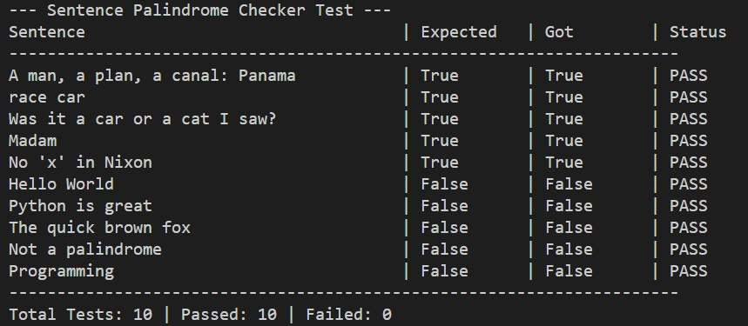
Task 4: ShoppingCart Class
Scenario: You are designing a basic shopping cart module for an e-commerce application.
Code:
#Task-04 class ShoppingCart:
"""A shopping cart class to manage items and calculate total cost."""

def __init__(self):
"""Initialize an empty shopping cart.""" self.items = {}

def add_item(self, name, price):
"""Add an item to the cart. Validates name and price.""" if not isinstance(name, str) or not name.strip():
return False if not isinstance(price, (int, float)) or price < 0:
return False

name = name.strip() if name in self.items:
self.items[name] += price else:
self.items[name] = price return True

def remove_item(self, name): """Remove an item from the cart.""" if not isinstance(name, str) or not name.strip():
return False

name = name.strip() if name in self.items: del self.items[name] return True return False

def total_cost(self):
"""Calculate and return the total cost of items in the cart.""" if not self.items:
return 0 return round(sum(self.items.values()), 2)

def is_empty(self):
"""Check if the cart is empty.""" return len(self.items) == 0
def test_shopping_cart():
"""Test cases for the shopping cart.""" print("--- Shopping Cart Test ---\n")

cart = ShoppingCart() print(f"Empty cart - Total: ${cart.total_cost()} | Is Empty: {cart.is_empty()}")

# Test add_item print("\nAdding items...") print(f"Add Apple($5): {cart.add_item('Apple', 5)}") print(f"Add Banana($2): {cart.add_item('Banana', 2)}") print(f"Add Orange($3): {cart.add_item('Orange', 3)}") print(f"Total: ${cart.total_cost()}")

# Test invalid additions print("\nTesting invalid inputs...") print(f"Add invalid price(-5): {cart.add_item('Grape', -5)}") print(f"Add empty name: {cart.add_item('', 2)}")

# Test remove_item print("\nRemoving items...") print(f"Remove Apple: {cart.remove_item('Apple')}") print(f"Total: ${cart.total_cost()}") print(f"Remove non-existent item: {cart.remove_item('Mango')}")

# Test empty cart print("\nEmptying cart...") cart.remove_item('Banana') cart.remove_item('Orange') print(f"Total: ${cart.total_cost()} | Is Empty: {cart.is_empty()}")
if __name__ == "__main__": test_shopping_cart() Output:
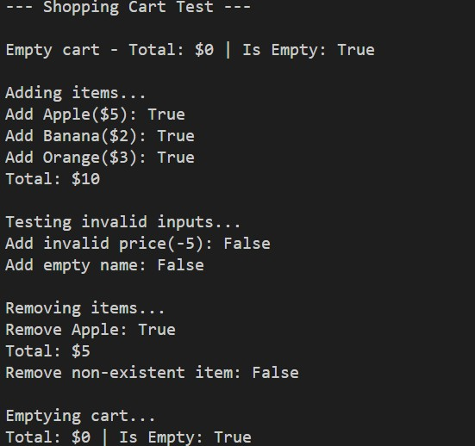
Task 5: Date Format Conversion
Scenario: You are creating a utility function to convert date formats for reports.
Code:
#Task-05 def convert_date_format(date_string):
"""Convert date from YYYY-MM-DD to DD-MM-YYYY format.""" if not isinstance(date_string, str):
return "Invalid input"

parts = date_string.split('-')

if len(parts) != 3:
return "Invalid format"

year, month, day = parts

if not (year.isdigit() and month.isdigit() and day.isdigit()):
return "Invalid input"

year, month, day = int(year), int(month), int(day)

if month < 1 or month > 12 or day < 1 or day > 31:
return "Invalid date"

return f"{day:02d}-{month:02d}-{year}"
def test_date_conversion():
"""Test cases for date format conversion.""" test_cases = [
("2024-01-15", "15-01-2024"),
("2023-12-25", "25-12-2023"),
("2022-06-30", "30-06-2022"),
("2024-02-29", "29-02-2024"), ("2023-13-01", "Invalid date"),
("2023-01-32", "Invalid date"),
("01-15-2024", "Invalid format"),
("2024/01/15", "Invalid format"),
("", "Invalid format"),
(None, "Invalid input"),
]

print("--- Date Format Conversion Test ---") passed = 0 failed = 0

for date_input, expected in test_cases: result = convert_date_format(date_input) status = "PASS" if result == expected else "FAIL" if status == "PASS":
passed += 1 else:
failed += 1

print(f"Input: {str(date_input):<20} | Expected: {expected:<20} | Got: {result:<20} | {status}")

print(f"\nTotal Tests: {passed + failed} | Passed: {passed} | Failed: {failed}")
if __name__ == "__main__": test_date_conversion() Output:
